Assignment – ETL Using Tableau Prep

Data Files: employee_info.xlsx
employee_payroll.csv

- Connecting to Data
  - Add the Addresses spreadsheet as input from the employee_info.xlsx workbook.
  - Change the type of the Postal_Code column to String.
  - Rename the Step as Employee Addresses.
  - Add the data set employee_payroll.csv to the workflow.
  - Do not include the columns for Marital_Status or Dependents.
  - Rename the Step as Employee Payroll.
- Examining, Cleaning, and Transforming Data
  - Add a Clean step to Employee Payroll.
  - Create a new column named Bonus that represents 1.5% of the Salary column.
  - Include only active employees in the output table. In other words, only include those that have a missing value for Employee_Term_Date.
  - Create a new column named New_Salary, which is the current salary plus an additional
2% raise.
  - Rename the Salary field to Old_Salary.
  - Create a new column named Years_Employed that calculates the number of years that each employee worked at Orion Star, based on the hire date and today's date.
Hint: The TODAY() function can be used to provide the current date. You also need to transform the Employee_Hire_Date to the Date type using the function of DATE().
  - Change the values for the Employee_Gender column (i.e., change “F” to “Female” and “M” to “Male”).
  - Add a Clean step to Employee Address.
  - Examining the City column, we found that Miami-Dade is a county name, not a city name. Change the value Miami-Dade to Miami.
  - In the data, you may notice that the State column values have inconsistent spellings (e.g., “PA” and “Pa”). Make all values in the State column to Uppercase.
  - In the Country column, spell out the code “AU” and “US” to “Australia” and “United States”, respectively. This will help create the data role.
  - Assign data role to the columns of City, State, and Country to their corresponding roles.

- Joining Data from Two Tables
  - Use the Join step to join Employee Payroll and Employee Addresses on the Employee_ID column. Rename the step as Payroll Location Join Query.
  - Only keep useful columns by excluding the following data columns: Employee_ID-1, Street_ID, Employee_Hire_Date, Employee_Term_Date.
- Aggregating Data
  - Add a Step of Aggregate after the Payroll Location Join Query. Rename the aggregation step as Employee Information by City.
  - Show the total number of employees, the average years employed, the average salary (use Old_Salary column) of male and female at each city. Your result will look like:
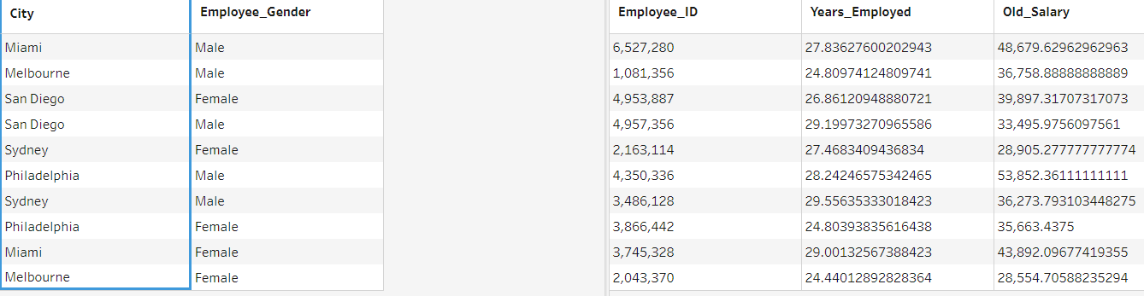
- Output
  - Add an Output step after the joining query.
  - Rename it as Output_Employee_Info and save it to a Tableau Data Extract file.

After you complete the assignment, save the Tableau Prep flow. Turn this file to the Canvas Folder.

